Career Group Careers
Technical Reference & Maintenance Guide
BX Studio · Prepared for Career Group Companies · October 14, 2026
Webflow hosts the careers pages, Bullhorn stays the system of record, and a Hono API on Vercel is the only component that talks to Bullhorn. Jobs are not copied into a Webflow CMS collection, and the browser never calls Bullhorn. This document has two parts: a full technical reference (architecture, API, Bullhorn mapping, caching, security, configuration and deploy), and a maintenance guide for the Webflow markup, publishing jobs in Bullhorn, and day-to-day changes.

Part 1 — Technical Reference

1.1 System Overview
Every job a visitor sees is read live from Bullhorn through the API. There is no sync job, no cron, and no database. The only state is the Vercel CDN cache (5 minutes fresh, 10 more minutes stale) and in-memory caches inside a warm Node instance. Bullhorn credentials and the Google Maps key exist only as Vercel environment variables.
An application from the detail page becomes three things in Bullhorn: a Candidate (matched by email, created if new), a JobSubmission against the JobOrder (created once per person per job), and a resume file attached to the Candidate.
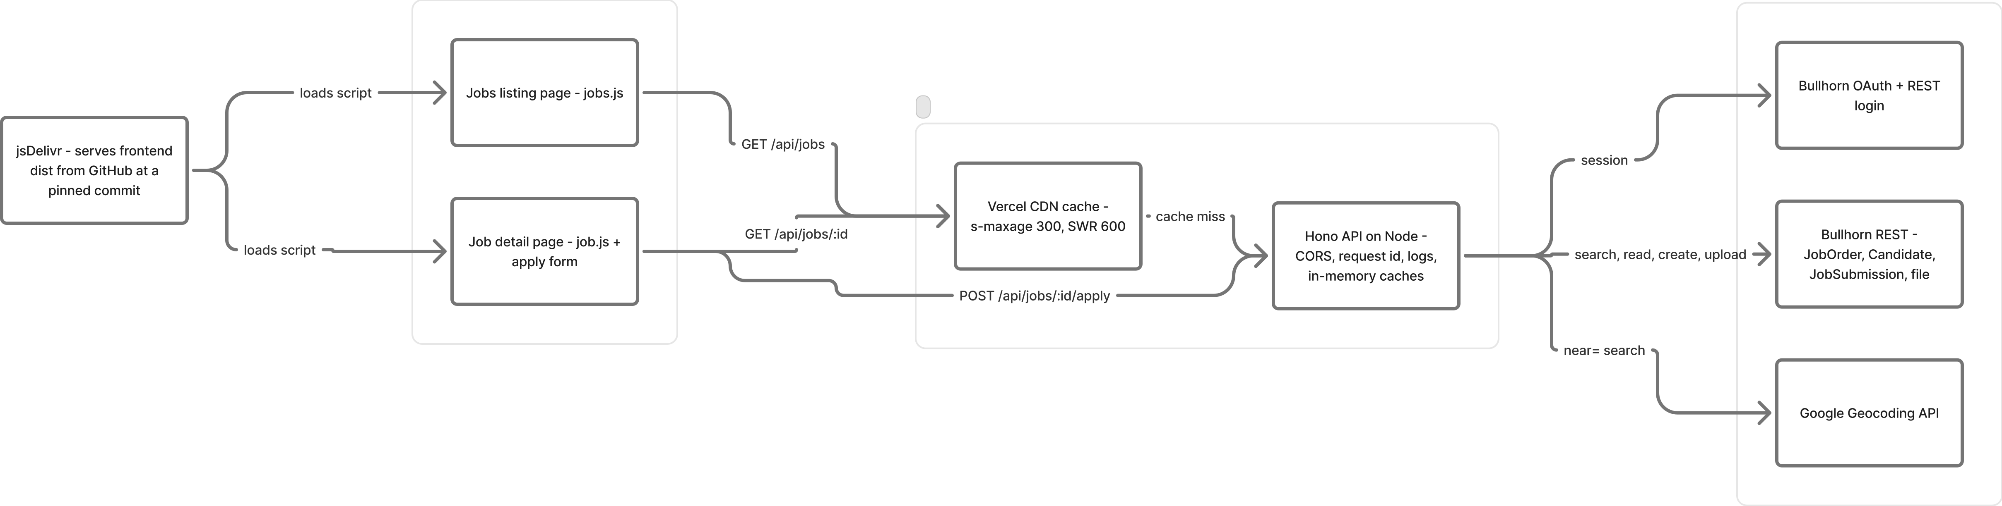
System architecture — Webflow, jsDelivr, Vercel (CDN + Hono API), Bullhorn and Google Geocoding.
Editable FigJam board: https://www.figma.com/board/0Xpz5gXMDTdn55Aheout08/Career-Group-Careers-%E2%80%94-System-Architecture

1.2 What Each Part Owns
Piece | Role
Webflow listing page | Hosts the job card template, filter groups, keyword and location inputs. Loads jobs.js.
Webflow detail page /dev/job-posting-dev?id= | Hosts the job layout, the six division cards and the apply form. Loads job.js.
jobs.js | Loads up to 500 published jobs (200 per request), renders the cards, and runs every filter in the browser. Only the location box calls the API again (near=).
job.js | Reads ?id, renders the job, validates the apply form, and posts it as multipart. Blocks Webflow’s own form submit.
jsDelivr | Serves the committed packages/frontend/dist files from GitHub, pinned to a git commit.
Vercel CDN | Caches the two GET job routes for 5 minutes, then serves stale for up to 10 minutes while it refreshes.
Hono API (packages/server) | Holds the Bullhorn session and all secrets. Validates input, maps JobOrders to public DTOs, writes applications.
Bullhorn ATS | System of record for JobOrders, Candidates, JobSubmissions and resume files.
Google Geocoding | Resolves the visitor’s location and job cities for the 50-mile radius search. Server-side only.

1.3 Browser Request Flow
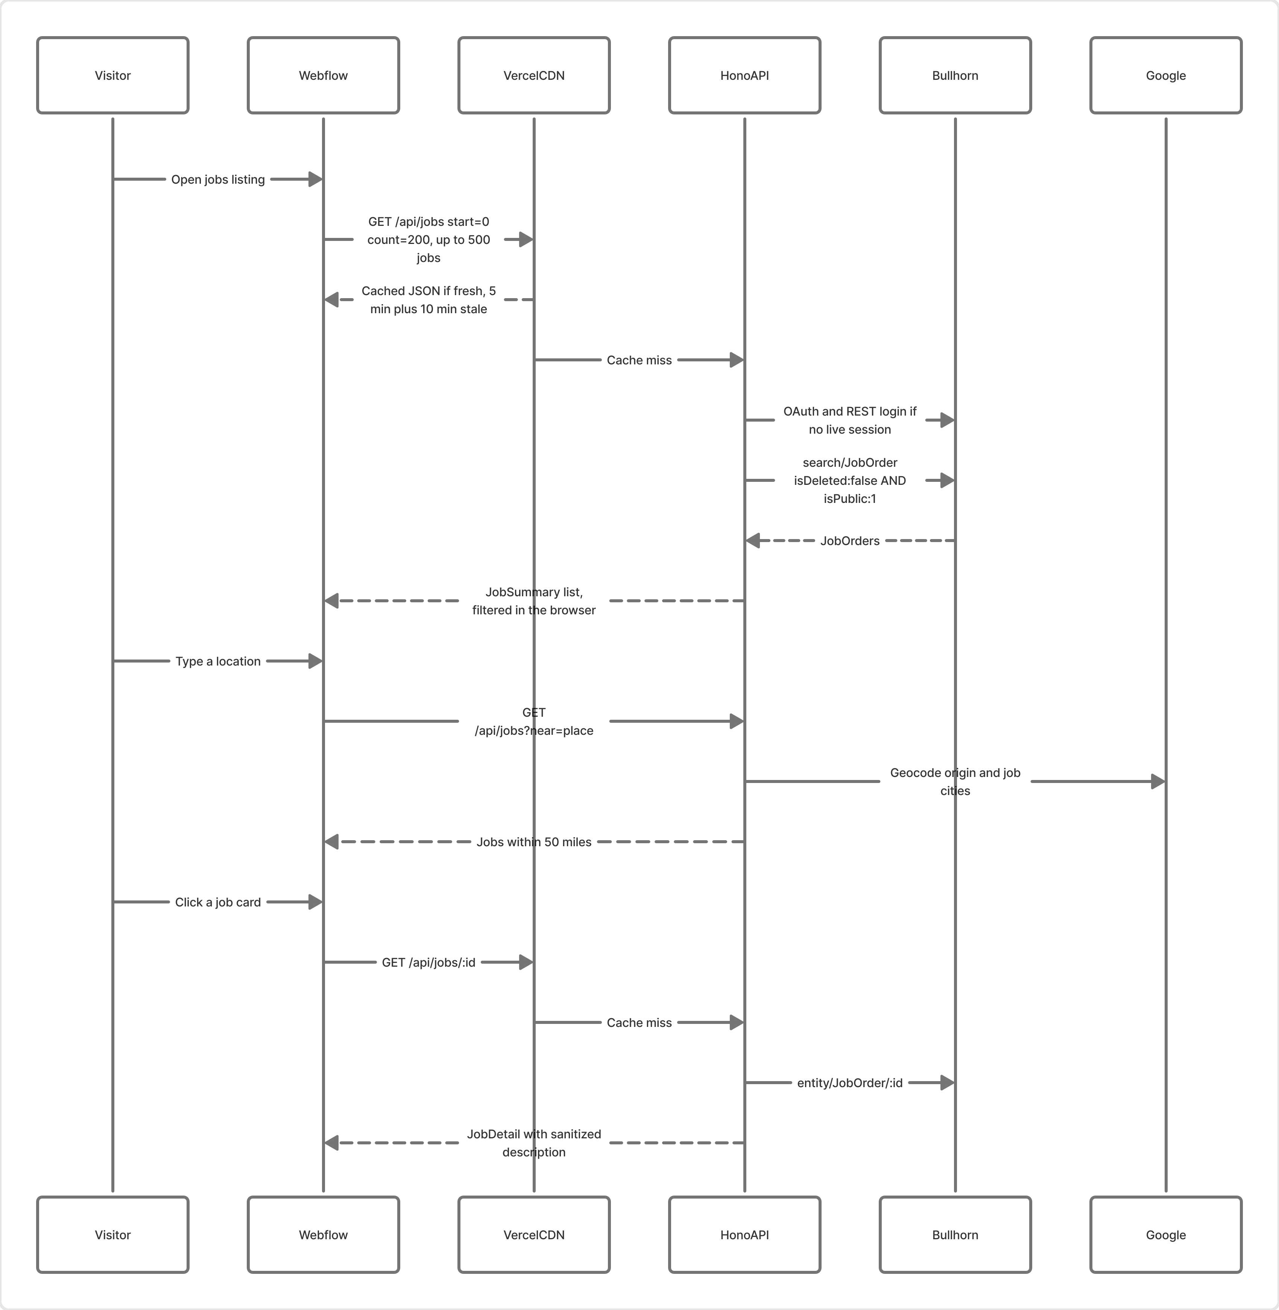
Listing, location search and detail page sequence.
The listing page pages through GET /api/jobs?start=N&count=200 until it has every published job (capped at 500), de-duplicates by id, and filters in the browser — the q, location and category server filters exist but the page does not send them. The location box waits 400 ms and calls GET /api/jobs?near=<text>; a resolved place replaces the list with jobs inside 50 miles and the other filters still apply. If Google cannot resolve the text (422), the script falls back to a substring match on loaded job locations.
A card links to the list’s detail-path attribute (default /dev/job-posting-dev) plus ?id=. The detail page calls GET /api/jobs/:id and inserts the sanitized public description as HTML.

1.4 API
Base URL: https://career-group.vercel.app. Every request runs CORS, then a request id (X-Request-Id, echoed back), then a one-line JSON request log. Errors always return { ok: false, error, message } with Cache-Control: no-store.
Route | Method | Purpose
/health | GET | Returns { "ok": true, "status": "ok" }.
/api/jobs | GET | Published job list, or a 50-mile radius search when near is set.
/api/jobs/:id | GET | One published job, including the sanitized public description.
/api/jobs/:id/apply | POST | Multipart application. Creates or updates the Candidate, the JobSubmission and the resume file.

GET /api/jobs query parameters:
Param | Rule
q | Up to 100 characters. Title prefix, sent to Bullhorn as title:<escaped>*.
location | Up to 80. Exact address.city.
category | Up to 80. Exact Job Function (customText5).
near | Up to 80. A place such as Austin, TX. Scans at most the first 500 published jobs.
start | Integer 0–10,000. Default 0.
count | Integer 1–200. Default 50.

Status | error | When
400 | invalid_query | A list parameter fails validation.
400 | invalid_job | The id is not 1–15 digits.
400 | invalid_application | The body cannot be read, a field fails validation, or the resume is missing, the wrong type, or over 10 MB.
404 | not_found | The job is missing, deleted, unpublished or future-dated — or the route does not exist.
422 | unresolved_location | Google could not resolve near.
500 | configuration_error | A required Bullhorn variable or GOOGLE_MAPS_API_KEY (for near) is missing.
500 | internal_error | Unexpected throw. Message is “Request failed.”
502 | bullhorn_unavailable | Bullhorn returned an error, including a 429 rate limit (not retried).
502 | maps_unavailable | Google Geocoding failed.

1.5 Bullhorn Field Mapping
A job is public when isDeleted is false and isPublic is on; the search query is isDeleted:false AND isPublic:1 (isPublic:true matches nothing in this corp), sorted by -dateLastPublished. After the search, a job with a future publish date or no public title is dropped. Closed jobs stay listed while the public flag is still on.
Careers value | JobOrder field
Public title | customText15, then title
Location | address.city + state abbreviation, e.g. San Francisco, CA. A non-US country is appended; “None Specified” is dropped.
Employment type | employmentType
Category (Job Function) | customText5, then publishedCategory.name
Annual pay | customFloat1 min, customFloat2 max
Hourly pay | payRate min, customFloat3 max — used only when both annual amounts are empty
Hide salary | customText12 = Yes blanks the amounts
Worksite | customText10. Cards show Remote or Hybrid; Onsite and blank stay hidden.
Division | customText20 code (see below)
Posted date | customDate1 (Published Date), then dateLastPublished
Card preview | customText4, otherwise a plain-text excerpt of publicDescription cut near 220 characters
Description | publicDescription, with script, iframe, object, embed, on*= handlers and javascript: stripped

Code | Division | Colour
CG | Career Group | #b9373d
SB | Syndicatebleu | #00abc7
FF | Fourth Floor | #51afe2
CGS | Career Group Search | #bab4ae
Event / Events | Career Group Events | #f62dae
CGC | CGC Internal | none

An unknown division code is shown as stored. clientBillRate is never shown as pay.

1.6 Application Flow
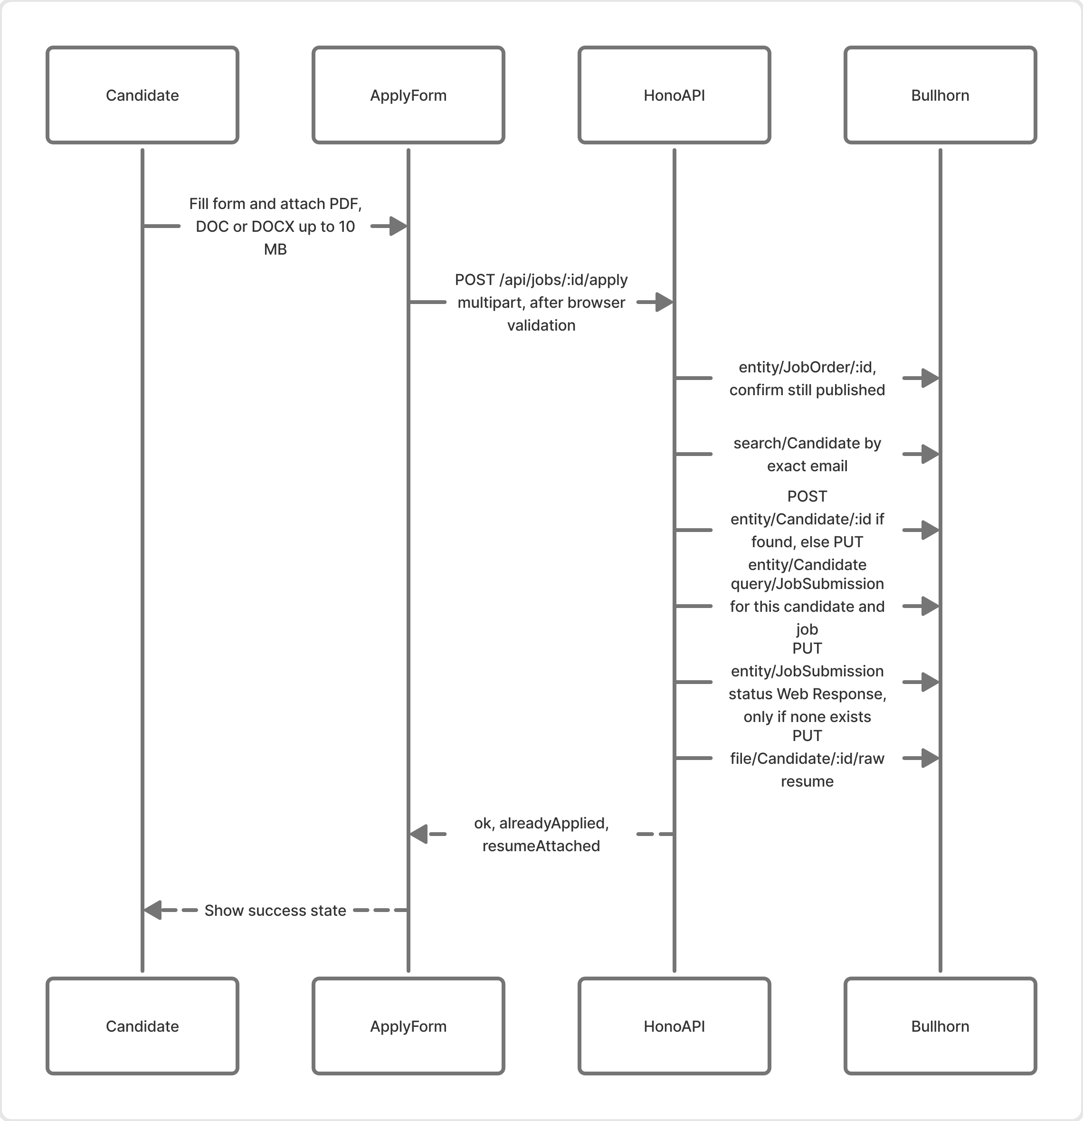
Apply sequence — from the Webflow form to Candidate, JobSubmission and resume in Bullhorn.
The browser validates first and joins every problem into one message; the server re-checks the same rules with zod, lowercases the email and cleans the filename (basename only, [\w.\- ], 120 characters max). Then:
- entity/JobOrder/{id} confirms the job is still published, otherwise 404.
- search/Candidate with Lucene email:"…", then an exact case-insensitive email match.
- If found, POST entity/Candidate/{id} updates the form fields only (no status, recruiter fields untouched). If not, PUT entity/Candidate creates one, with status from BULLHORN_CANDIDATE_STATUS when set (New Lead).
- query/JobSubmission where candidate.id and jobOrder.id match. A hit sets alreadyApplied: true and no second submission is created.
- Otherwise PUT entity/JobSubmission with status from BULLHORN_SUBMISSION_STATUS (default Web Response) and dateWebResponse = now.
- PUT file/Candidate/{id}/raw uploads the resume as fileType=Resume. It runs on every accepted application, including repeats. This account does not accept files on a JobSubmission.
The response is { "ok": true, "alreadyApplied": false, "resumeAttached": true }. A failed upload still returns 200 with resumeAttached: false, because the candidate and submission were already written. A Bullhorn failure before that returns 502.
The record from step 5 is an internal JobSubmission, not Bullhorn’s separate WebResponse entity. The status string “Web Response” is not in this corp’s JobSubmission status picklist.
Form value | Candidate field
First name, last name | firstName, lastName, and name (both, cut at 100)
Email, phone | email, phone
City, state | address.city, address.state
Referral | source: Instagram → Instagram; Internet Search → Internet/Google Search; LinkedIn → LinkedIn Search (non-breaking space, as in the picklist); Referred by a peer → Referral - Applicant referred Applicant; everything else → Other
LinkedIn URL | customText8, only when filled
Portfolio URL | companyURL, only when filled
New candidate only | status from BULLHORN_CANDIDATE_STATUS

1.7 Bullhorn Authentication
The API logs in as a dedicated Bullhorn API user using Bullhorn’s server-side OAuth flow. The session is held in memory by one client per warm Node process; nothing is persisted, so a cold start logs in again. The FigJam board has the full session lifecycle diagram.
Step | Call | Notes
1. Discover | GET rest-services/loginInfo?username= | Returns the cluster’s OAuth and REST hosts.
2. Authorize | GET oauth/authorize | response_type=code, action=Login, username, password, redirect_uri. The code is read from the redirect.
3. Token | POST oauth/token | grant_type=authorization_code. Returns access and refresh tokens.
4. REST login | POST rest-services/login?version=* | Returns BhRestToken and restUrl for every later call.
Refresh | POST oauth/token | 30 s before expiry, grant_type=refresh_token. Falls back to a full login if refresh fails.
401 retry | — | Any 401 clears the session and retries the call once.

The registered redirect URI must be exactly http://www.bullhorn.com. A new API user must accept Bullhorn’s OAuth consent page once for this client id before a code is returned. Bullhorn limits per client id: 1,500 requests/minute, 100,000 calls/month, 50 concurrent sessions. The API never asks for more than 200 rows per call and does not retry 429.

1.8 Caching
Layer | What | Lifetime
Vercel CDN | GET /api/jobs and GET /api/jobs/:id: public, s-maxage=300, stale-while-revalidate=600 | 5 min fresh + 10 min stale
API memory | Each job list (incl. near), keyed by query | 5 min
API memory | Each published job detail, keyed by id | 5 min
API memory | Geocoded places, including unresolved ones | Life of the instance
API memory | Bullhorn session | Until 30 s before token expiry
None | Apply route and every error (no-store). The frontend caches nothing. | —

A Bullhorn edit typically shows on the site within 5–10 minutes; the worst case is about 15 minutes (CDN stale window plus a memory-cached copy).

1.9 Gates and Security
Check | Where | Result
CORS origin | API, every request | Allowed: CORS_ORIGINS list plus careergroupcompanies.com, webflow.io and their subdomains. Others get no ACAO header. * echoes any origin — local use only.
Job id | job.js and API | ^[1-9]\d{0,14}$, otherwise “This job link is incomplete.” / 400.
Form fields | job.js, then API (zod) | Required fields, length limits, http(s) URLs, PDF/DOC/DOCX up to 10 MB.
Lucene injection | API | Title, city, category and email are escaped. Submission lookup uses numeric ids only.
Description HTML | API | Regex-stripped of script, iframe, object, embed, on*= and javascript: before job.js inserts it.
Secrets | API only | Bullhorn and Google credentials never reach the browser (covered by tests).
Webflow form | job.js | Capture-phase submit handler: no application data goes to Webflow Forms.

1.10 Configuration and Secrets
Variable | Used for
BULLHORN_CLIENT_ID / BULLHORN_CLIENT_SECRET | OAuth client. Required.
BULLHORN_API_USERNAME / BULLHORN_API_PASSWORD | Dedicated API user. Required. A missing required value fails closed with 500 configuration_error.
BULLHORN_REDIRECT_URI | Default http://www.bullhorn.com. Must match the registered URI exactly.
BULLHORN_SUBMISSION_STATUS | JobSubmission status. Default Web Response.
BULLHORN_CANDIDATE_STATUS | Status for new candidates only. This corp uses New Lead.
CORS_ORIGINS | Comma-separated allowlist, e.g. https://www.careergroupcompanies.com,https://careergroupcompanies.com.
GOOGLE_MAPS_API_KEY | Geocoding. Needed only for near searches.
PORT | Local API port. Default 8787.
CAREERS_API_ORIGIN | Build-time override of the API origin baked into the frontend.

Production values are Vercel project environment variables (project root packages/server). Locally, copy packages/server/.env.example to packages/server/.env — never commit it.

1.11 Build, Deploy and Local Development
Command | Description
pnpm dev | Frontend watcher on port 3000 (live reload) and the API on port 8787
pnpm test | API tests (vitest, mocked fetch)
pnpm lint / pnpm check | ESLint and TypeScript checks for both packages
pnpm --filter @career-group/frontend build | Write the minified packages/frontend/dist
pnpm --filter @career-group/server deploy | vercel deploy --prod — production API

CI (.github/workflows/ci.yml) runs on pull requests only: install, build, lint, check and test on Node 22 with pnpm 10. It does not deploy. The API process does not hot-reload locally; restart it after a server or .env change.
A frontend change is live only after a production build of packages/frontend/dist is committed and the jsDelivr @<commit> pin in Webflow is updated and published. Never commit a development build: it points at http://localhost:8787 and includes the live-reload client.

1.12 Known Limitations
Limitation | Impact | Option
Vercel body limit ~4.5 MB | Resumes between 4.5 and 10 MB pass the browser check but are rejected before the handler, so the user sees the generic “could not be submitted” message. | Lower the limit to 4 MB, or upload resumes directly to storage first.
No rate limit or captcha | Anyone who can POST can create candidates and submissions; near can drive Google cost. | Add Vercel firewall rules, Turnstile, or a honeypot.
Regex HTML sanitizer | Best-effort only on recruiter-authored descriptions. | Swap in an allowlist sanitizer.
Unbounded geocode cache | Grows with each distinct place until the instance recycles. | Add a size cap or TTL.
Cold near search | Can geocode many job cities in sequence on a cold instance. | Pre-geocode or store coordinates.
429 not retried | A Bullhorn rate-limit burst shows as 502. | Add backoff for 429.

Part 2 — Maintenance Guide
This is the day-to-day guide for the Webflow markup and for getting jobs on and off the site, without touching the API code. Webflow only provides the layout: the scripts find elements by their dev-target attribute and fill them from Bullhorn.

2.1 Production Scripts
Listing page:
<script defer src="https://cdn.jsdelivr.net/gh/BX-Studio-Webflow/career-group@<commit>/packages/frontend/dist/pages/jobs.js"></script>
Detail page:
<script defer src="https://cdn.jsdelivr.net/gh/BX-Studio-Webflow/career-group@<commit>/packages/frontend/dist/pages/job.js"></script>
Replace <commit> with the git commit that contains the production build. Set window.CAREERS_API_ORIGIN in a script above only when the API host must change without a rebuild. OneTrust must allow both jsDelivr and career-group.vercel.app.

2.2 Pages
Page | What it does
Jobs listing page | jobs.js — loads published jobs, renders cards, runs filters, keyword and location search.
/dev/job-posting-dev?id=<jobId> | job.js — shows one job, colours the highlights by division, shows the matching division card, handles the apply form.

If the detail page moves, set the detail-path attribute on the jobs-list element to the new path; the cards will link there.

2.3 Listing Page Markup
dev-target | Purpose
jobs-list | Card container. Optional detail-path attribute.
job-card-item | First one is cloned as the card template, then removed.
division-chip | Division name and colour on a card.
remote-role / remote-text | Worksite row, shown for Remote or Hybrid only.
search-input | Keyword box — title and location of loaded jobs, no API call.
location-search-input | 50-mile radius search via near.
division-checkbox-wrapper | Six division options, generated from a template option.
employment-type-checkbox-wrapper | Direct Hire, Temp to Hire, Temp (each also matches Bullhorn synonyms).
salary-radio-wrapper | Annual minimums $40k to $200k. Hourly pay is annualised at 2,080 hours.
job-function-checkbox-wrapper | 26 Job Function labels from shared/filters.ts.
remote-only-checkbox-wrapper | Remote-only toggle.
clear | Resets every filter and search.
filter-wrapper / filter-trigger / filter-close | Mobile (≤767px) filter drawer.
results | Results count line (or .results).

Card text fields use the Finsweet names fs-cmsfilter-field = title, location, type, category, salary, remote, preview. Finsweet itself is disabled by the script. Values in one filter group are OR’ed; groups are AND’ed. A job counts as new when published on or after midnight four days ago (.new-job-text).

2.4 Detail Page Markup
dev-target | Filled with
job-title | Public title (also sets the browser tab title)
job-location, job-type, job-category | Location, employment type, Job Function
job-salary | Range, e.g. $30/hr–$36/hr; yearly amounts have no suffix
division | Division name
job-highlights | Background colour set to the division colour
job-description | Sanitized public description (HTML)

Division | Card dev-target
Career Group | division-card-career-grp
Syndicatebleu | division-card-syndicate
Fourth Floor | division-card-fourth-floor
Career Group Search | division-card-career-grp-search
Career Group Events | division-card-career-grp-events
CGC Internal | division-card-career-grp-companies

All division cards start hidden; only the matching one is shown.

2.5 Apply Form
The form is [dev-target="apply-form"] inside [dev-target="form-wrapper"]. The submit button shows its data-wait label while sending.
Form dev-target | Sent as | Required | Limit
first-name / last-name | firstName / lastName | Yes | 50
email | email | Yes | 100, valid email
phone | phone | Yes | 50
city / state | city / state | Yes | 100
referral | referral | Yes | One of the eight labels below
linkedin-url | linkedinUrl | No | 100, http(s)
porfolio (sic) | portfolioUrl | No | 100, http(s)
file-upload | resume | Yes | PDF, DOC or DOCX, 10 MB

Referral labels (must match exactly): I'm an existing candidate, Instagram, Internet Search, Email Marketing, LinkedIn, Pinterest, Referred by a peer, Others.
Feedback elements — put these once on the detail page:
<div dev-target="form-error-wrapper" class="hide">
<p dev-target="form-error-text"></p>
</div>
<div dev-target="success-state" class="hide"></div>
<div dev-target="error-wrapper" class="hide">
<p dev-target="error-text"></p>
<button type="button" dev-target="cancel">Close</button>
</div>
On success the script un-hides success-state and hides form-wrapper; it does not change the success copy, so edit that in Webflow. A failing field gets the is-error class — style it in Webflow.

2.6 Messages Visitors Can See
Message | Cause
Loading jobs… | First page of jobs is in flight.
We could not find your jobs | Filters and search match nothing.
Jobs could not be loaded. Please try again. | The API or Bullhorn failed while loading the list.
Location search is unavailable right now. Please try again. | The near call failed (network, Google or configuration).
This job link is incomplete. | ?id= is missing or not numeric.
This job is no longer available. | The job is unpublished, deleted, future-dated or does not exist.
This job could not be loaded. Please try again. | Any other detail-page failure.
Resume must be 10 MB or smaller. | File over 10 MB.
Resume must be a PDF, DOC, or DOCX file. | Wrong file type.
Your application was submitted, but the resume could not be attached. | Candidate and submission saved; file upload failed.
You already applied for this job. | A submission for this email and job already exists (no success-state element).
Your application could not be submitted. Please try again. | Non-JSON response — usually a resume over ~4.5 MB rejected by Vercel, or a network failure.

2.7 Publishing a Job in Bullhorn
A JobOrder appears on the site when all of these hold:
- Publishing Status is on (isPublic) and the job is not deleted.
- It has a public title (customText15) or a title.
- Published Date (customDate1) is empty or not in the future — a future date schedules the job.
To take a job down, turn off Publishing Status. Closing a job alone does not remove it. Fill the fields in 1.5 for location, pay, worksite, Job Function, division and preview. Set Hide Salary (customText12) to Yes to blank the amounts. Changes appear within 5–10 minutes (up to about 15).

2.8 When Something Changes
Change | Where
New, edited or unpublished job | Bullhorn only. No Webflow publish needed.
Card or page design | Webflow. Keep the dev-target attributes and the first card template.
Detail page moves | Webflow: set detail-path on jobs-list to the new path.
New division, Job Function label or referral option | Engineering: update shared/divisions.ts, shared/filters.ts or bullhorn/application.ts, rebuild, commit dist, update the jsDelivr pin.
Change to jobs.js or job.js | Engineering commits the production dist. Update the <commit> pin in Webflow and publish.
API change or new secret | Engineering: update Vercel env vars, then pnpm --filter @career-group/server deploy.
Rotate Bullhorn API user password | Update BULLHORN_API_PASSWORD in Vercel and redeploy. A new user must accept OAuth consent once.

2.9 Troubleshooting
Symptom | Check
No jobs, “Jobs could not be loaded” | Open https://career-group.vercel.app/health, then /api/jobs. A configuration_error means a missing Vercel variable; bullhorn_unavailable means login or Bullhorn failed — check Vercel logs by request id.
A job is missing | Publishing Status, deleted flag, public title, and Published Date not in the future. Allow up to 15 minutes for caches.
Script does nothing | The jsDelivr pin points at a commit with a production build, OneTrust allows jsDelivr, and the browser console shows no CORS error for the Vercel host.
CORS error in console | The site origin is in CORS_ORIGINS or is careergroupcompanies.com / webflow.io.
Apply fails for larger files | Resume over ~4.5 MB (Vercel limit). Ask for a smaller PDF.
Location search always falls back | GOOGLE_MAPS_API_KEY is set in Vercel and the Geocoding API is enabled for that key.

